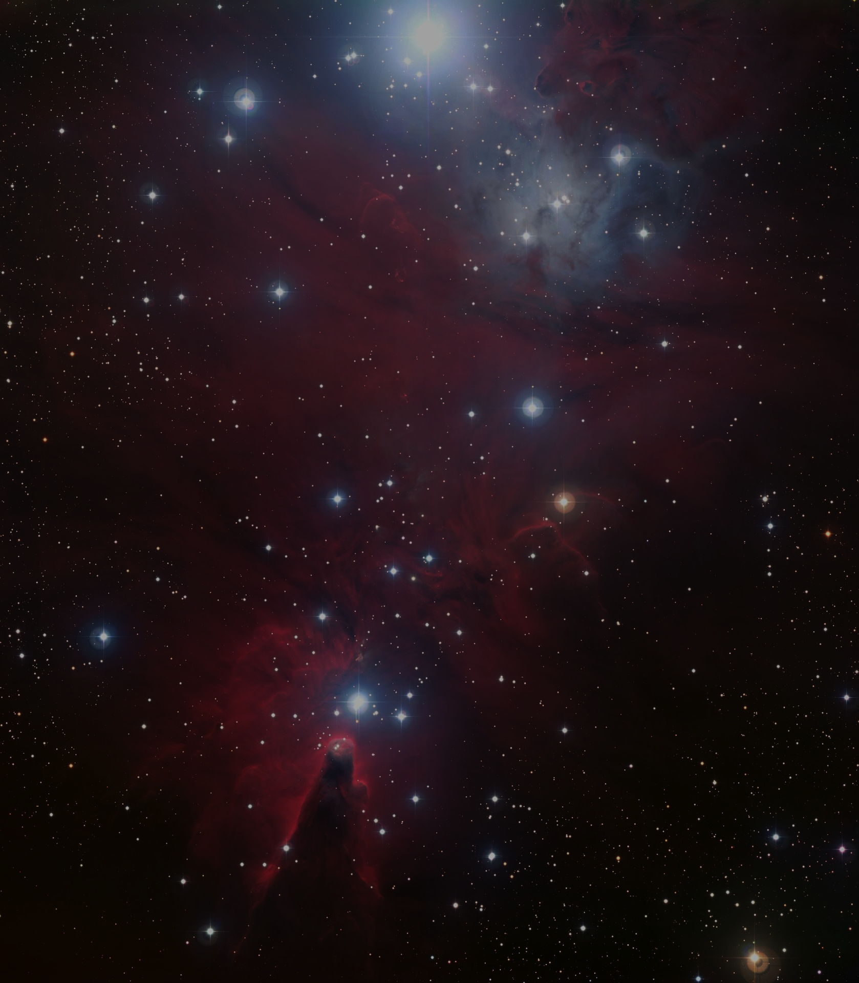

September

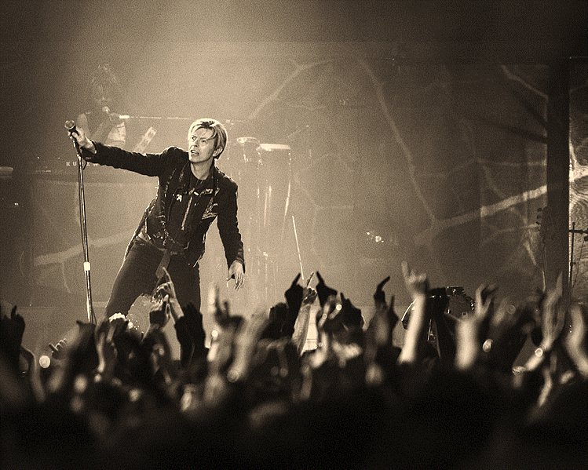

Rodrigo.Argenton, 2018: https://upload.wikimedia.org/wikipedia/commons/0/06/David_Bowie_%28135687113%29.jpeg

**Born :** Brixton, London 1947

**Died:** New York, U.S.A. 2016

**Famous Song:** Space Oddity

David

Bowie

